**Course1---Hello,World!**

****Learning goals:****

This lesson learns to scroll through the characters on a micro:bit dot matrix by Python programming.

**Code :**

from microbit import *

display.scroll("Hello, World!")

**Programming and downloading：**

1. You should open the Mu software, and enter the code in the edit window, , as shown in Figure 1-1.

**Note! All English and symbols should be entered in English, and the last line must be a space.**

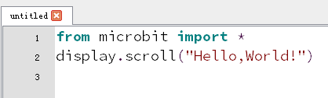

Figure 1-1

1. As shown in Figure 1-2, you need to click the Check button to check if our code has an error. If a line appears with a cursor or an underscore, the program indicating this line is wrong.

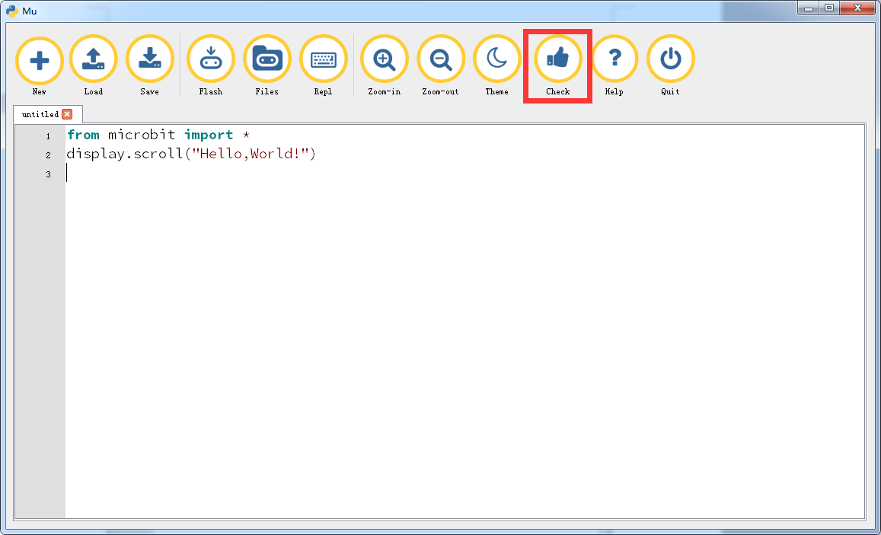

Figure 1-2

3. You need to connect the micro data cable to micro:bit and the computer, then click the Flash button to download the program to micro:bit as shown in Figure 1-3.

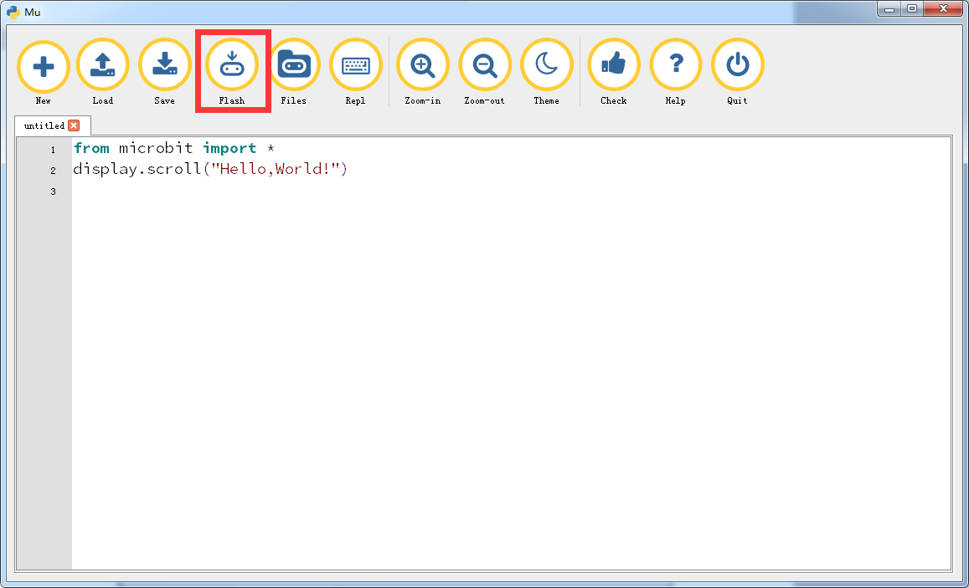

Figure 1-3

4.After the download is successful, you can see that the micro:bit dot matrix slowly moving to the left , "Hello, World!", as shown in Figure 1-4 and Figure 1-5.

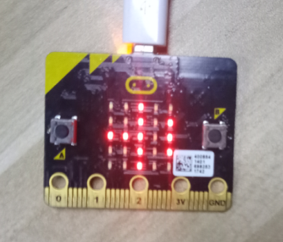 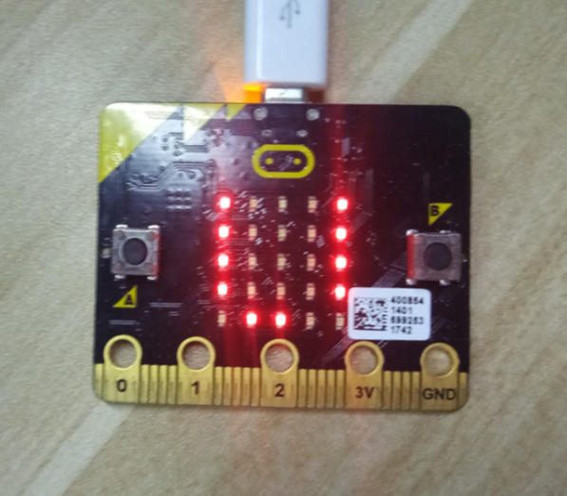

Figure 1-4 Figure 1-5